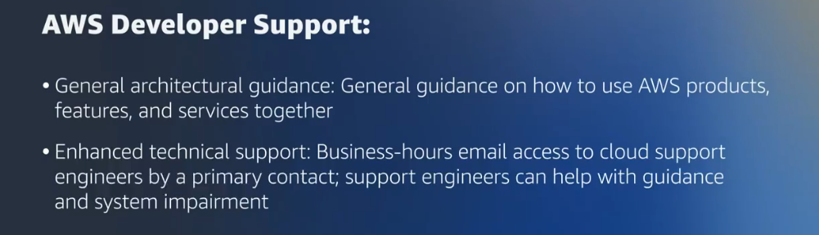
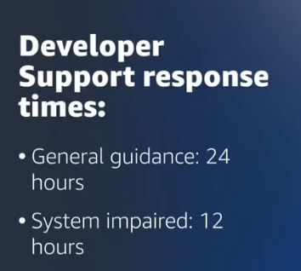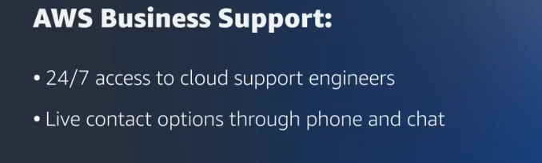
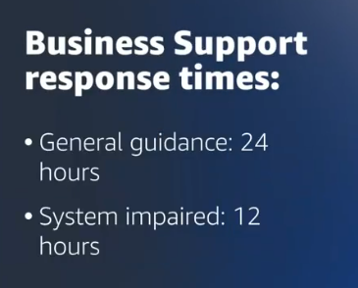
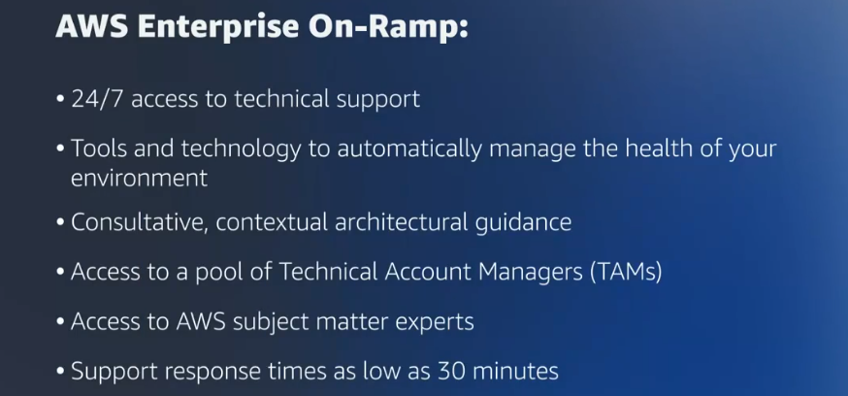
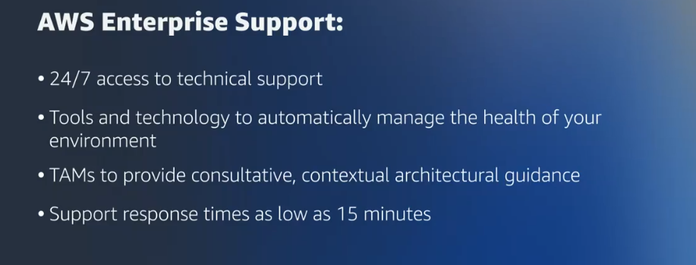
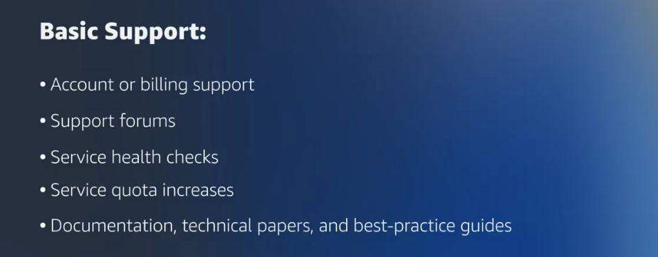
Here’s a clear, structured bullet-point version of your text:

🔑 How to Choose the Correct AWS Support Method
- Start with business requirements
  - Identify the type of workload running in the cloud.
  - Assess whether the workload can tolerate interruptions.
  - Determine urgency of issue resolution (consider SLAs, compliance, regulations).
- Evaluate available AWS Support case types
  - Account & Billing
    - Help with billing/account questions.
    - Free for all AWS customers.
    - Example: Create a Support Case for Account and Billing.
  - Service Limit Increase
    - Request increases to default service quotas.
    - Free for all AWS customers.
    - Example: Use AWS Service Quotas.
  - Technical Support
    - Assistance with service-related technical issues.
    - Available only with paid plans: Developer, Business, Enterprise On-Ramp, Enterprise Support.
- Understand default support (Basic Support)
  - Included for all customers at no charge.
  - Provides access to:
    - General customer service.
    - AWS documentation, whitepapers.
    - AWS re:Post community.
    - AWS Trusted Advisor.
    - AWS Health Dashboard.
- Consider higher-tier support plans
  - Offer faster response times and advanced features.
  - Useful for issues requiring expert assistance.
  - Compare AWS Support Plans to align with budget and needs.
- Decision factors for choosing a plan
  - Does the company have technical staff to troubleshoot issues?
  - Can staff resolve problems using free AWS resources?
  - Balance cost vs. level of assistance required.
  - Ensure chosen plan aligns with business priorities and compliance obligations.
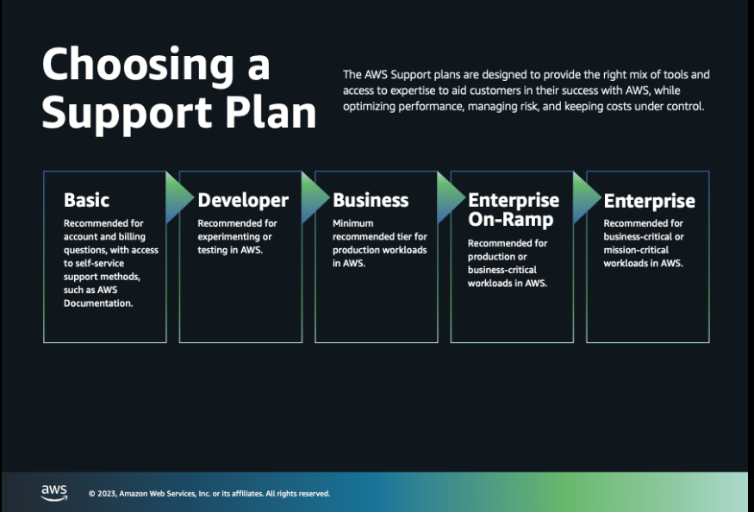
Here’s a structured bullet-point summary of your text:

🔥 Avoiding Fire Scenarios & Minimizing Customer Impact
- Definition of fire scenarios
  - Issues large enough to force reprioritization.
  - Typically impact customers, users, or cause operational disruption.
- Key prevention strategies
  - Plan ahead for potential risks.
  - Design systems with failure in mind.
  - Understand causes of issues to prevent escalation.
- Role of disaster recovery
  - Anticipates and addresses technology-related disasters/failures.
  - Ensures workloads/systems can recover and continue operating.
- Types of disasters
  - Natural events: earthquakes, fires.
  - Technology failures or incompatibilities.
  - Human errors.
  - Malicious third-party actions (e.g., cyberattacks).
- Benefits of disaster recovery planning
  - Business continuity: Quick restart of backup systems/data, minimizing disruption.
  - System security: Protects against ransomware, malware, and other risks.
  - Recovery cost reduction: Reduces losses and speeds return to normal operations.
- Best practices
  - Include disaster recovery at architecture, system, and application levels.
  - Explore disaster recovery options commonly used in the cloud.
  - Develop recovery plans and patterns tailored to scope/impact.
  - Test implementations to validate or correct recovery paths.
- Outcome
  - Planning, implementing, and testing prepares organizations for unexpected issues.
  - Minimizes customer impact and ensures resilience during disruptions.
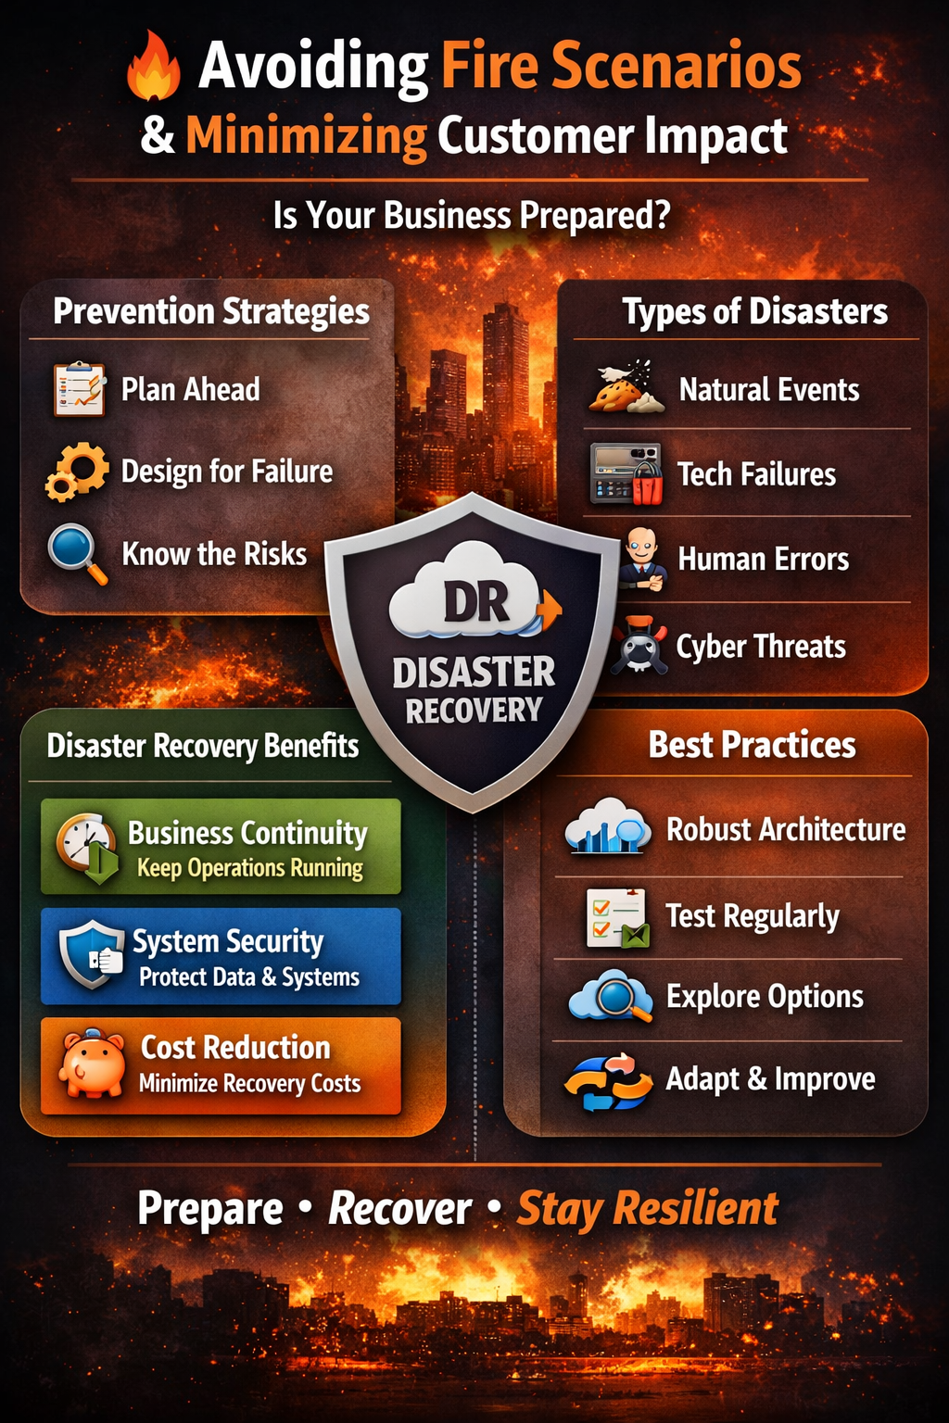
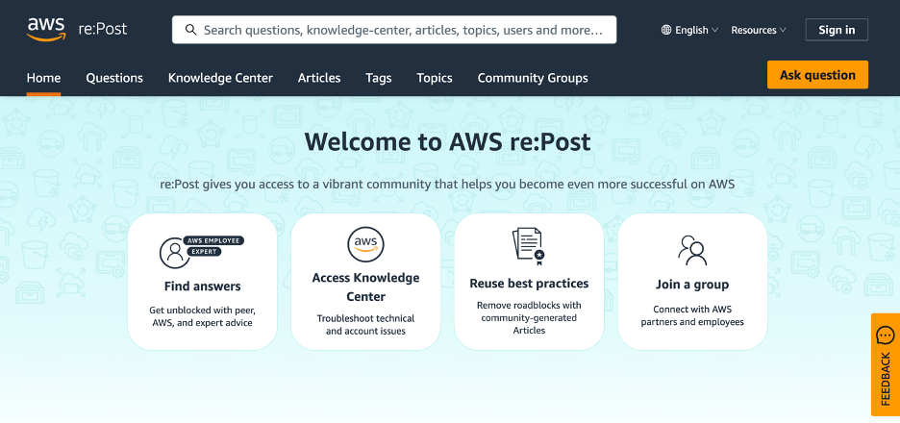
Here’s a concise bullet-point summary for Troubleshooting with AWS re:Post:

🛠️ Troubleshooting with AWS re:Post
- What is AWS re:Post?
  - A community-driven Q&A forum for AWS users.
  - Designed to share experiences, challenges, and solutions.
- Key features
  - Ask questions and join discussions.
  - Discover real-world examples and diverse viewpoints.
  - Explore innovative ideas for cloud troubleshooting.
- Community composition
  - Includes AWS experts, professionals, and enthusiasts.
  - Encourages collaborative problem-solving and learning.
- Integration with AWS Knowledge Center
  - Access to tutorials, articles, and technical discussions.
  - Helps build both theoretical and practical troubleshooting skills.
- Access and availability
  - Free to use under AWS Free Tier.
  - Available to anyone with an AWS account.
  - Visit: repost.aws
- Recommended resources
  - Introducing AWS re:Post – overview of the platform.
  - AWS re:Post Now Includes Knowledge Center Articles – expands learning resources.
